# 

# PATAN COLLEGE FOR PROFESSIONAL STUDIES

# Group Report (Group -1)

# Ujaalo Student Information Kiosk

# 

# PROJECT REPORT

# Submitted by Submitted to

# Kshitij Bajagain (172333) University Of Bedfordshire

# Buddha Lama (1723936) Luton

# Lokendra Dangi (1720849)

# Prabin Chapagain (1721484)

# Prajwol Thapa (1727479)

# 

# ACKNOELEDGEMENT

We would like to express our deepest and sincere appreciation to the unit coordinator **Mr.** **Bishwo Kumar Bhhatari**, **HOD Dr. Swati Shah, and Dean Academics Er. Ajaya Sharma** for supervising and guiding our group to understand the core concept of the project during whole software development phase. We would be thankful toward every group member who gave their valuable time for competition of their own individual role to the project. We would also like to thank to the staff of the **Patan College for professional studies** who played crucial role for the completion of the project. At last we would like to show appreciation to the University of the Bedfordshire and our parents for encouraging and motivating us to complete this project.

# 

# ABSTRACT

**Ujaalo Kiosk** is student information system which provides the function of viewing and booking community events / campus events in order to help students and general people to get aware of events occurring both in campus and community. Proper research and study was carried out to figure/identify the best solution for helping students and general people regarding events within and outside campus premises. We hope that our proposed system Ujaalo Student Information Kiosk will solve the problem of student and general public regarding campus details and events within and outside the campus premises.

Contents

1

ACKNOELEDGEMENT 2

ABSTRACT 3

1. Introduction 7

2. Aims and objectives 7

3. Design and Implementation 8

**1.** **Low Fidelity** 9

**2.** **Mid Fidelity** 10

**3.** **High Fidelity** 11

11

11

**4.** **Use-case Diagram** 12

**5.** **Activity Diagram** 13

**6.** **Sequence Diagram** 14

**7.** **Entity Relationship Diagram** 15

8. **Class Diagram**…………………………………………………………………………..16

Market Research 16

1. Primary Research 16

Software Methodology 16

**Agile Methodology** 16

Sprint 1 17

Sprint 2 17

Sprint 3 18

Project Plan 19

Weekly Report 19

Critical Analysis 20

Conclusion 21

# Work Division

|  |  |  |  |
| --- | --- | --- | --- |
| **S. N.** | **Name** | **GUI &**  **Implementation** | **Diagrams &**  **Documentation** |
| 1 | Kshitij Bajagain | Student Dashboard , Events & Booking, My/All Booking , Account Details ,Clubs , Admin Dashboard design and their functionalities | ER Diagram, Class Diagram, Design and implementation, work division. |
| 2 | Lokendra Dangi | Add Events , Alter Events , Update Events, design and their functionalities | UseCase Diagram, Class Diagram, Introduction of report, Testing part. |
| 3 | Buddha Lama | Register Page , Login Page , Why Us , Help, Brochure, Accommodation , User Information(admin) design and their functionalities | Sequence Diagram, Class Diagram. Project plan. |
| 4 | Prabin Chapagain | Browser Functionality , Campuses (Luton, Bedford, Aylesbury, Milton Keynes, Putter ridge , Patan College) ,Education Loan, Delete Events | Activity Diagram, Class Diagram, agile and primary research. |
| 5 | Prajwol Thapa | Splash Screen , Kiosk Main Home Courses(Undergraduate , graduate , Foundation and International Students) , Invoice Generation | Sequence Diagram, Class Diagram, aims and objectives and critical analysis. |

# Introduction

A kiosk is a small stand-alone booth typically placed in high traffic area for the business purposes. It provides information and application on education, commerce, entrainment and variety of others topic. Mainly kiosk is installed at the hospital, government offices, hotel lobbies or apartment offices. Common types of kiosk are touch screen kiosk, internet kiosk, photos kiosks, self-service kiosk, product promotion kiosk, directory and information kiosk and many more. A student information kiosk is a kiosk which provide (allow) students to access an electronic services shop. The kiosk provides information about all event taking places on campus as well as selected information that seek to place within the context of the local community. The system also provides information about services, discounted shopping, special offers, gym, and sport activates. Thus, system is enabling from both home and overseas as well as provide support student with Luton and Patan community. The student information kiosk provides support bank loans and extra curriculum activities. Student can search both campus and community event directly from search bar. The student information kiosk keeps the record of every student along with the course enrolled. Student can book their ticket of the event directly from kiosk. To booked ticket student should register to the system and keep login to the system with University id, email and password. Student can update their booking details before the event date at any time. The student information kiosk has three level of user i.e. student, admin, and guest. Mainly admin user has full privileges of update system and update booking details, but admin user does not have privileges of cancel the student booking. Another user in our system is guest who have the privilege of viewing the community event and campus information without login. Last user in our system is student itself who have the privilege of booking the event, update my bookings details, cancel booking, update credentials, enroll the course, view prospectus, and he has privilege of the BREO through the kiosk. (Fitsmallbusiness.com, 2019)

# Aims and objectives

The primary aim of the student information kiosk is to automate the process of the day to day activities of the student in campus operation such as cultural event, community event, sport activities, and to make the effectiveness by keeping student update about the campus and community. Here is some main objective of the student information kiosk.

* To improve campus administration with digital platform.
* To keep student update with campus and community events.
* To provide student with community and local services.
* Help student to save time.
* To validate the actual student of the campus.

# Design and Implementation

Design and implementation play a vital role for the user acceptance of the software. So, we also consider the design part as important part of the project. We design the student information kiosk on the basic of the primary research result rather than our own design. For the better user acceptance user interface, we divided the design part in to three phases. In the first phases we design the GUI’s on paper and refine again and again according the requirement given by the university as well as consider the student needs and desired. In the second phases we design in to Mock plus and Adobe XD by choosing different color combination, icons and images. At last we implement our design through coding.

## **Low Fidelity**

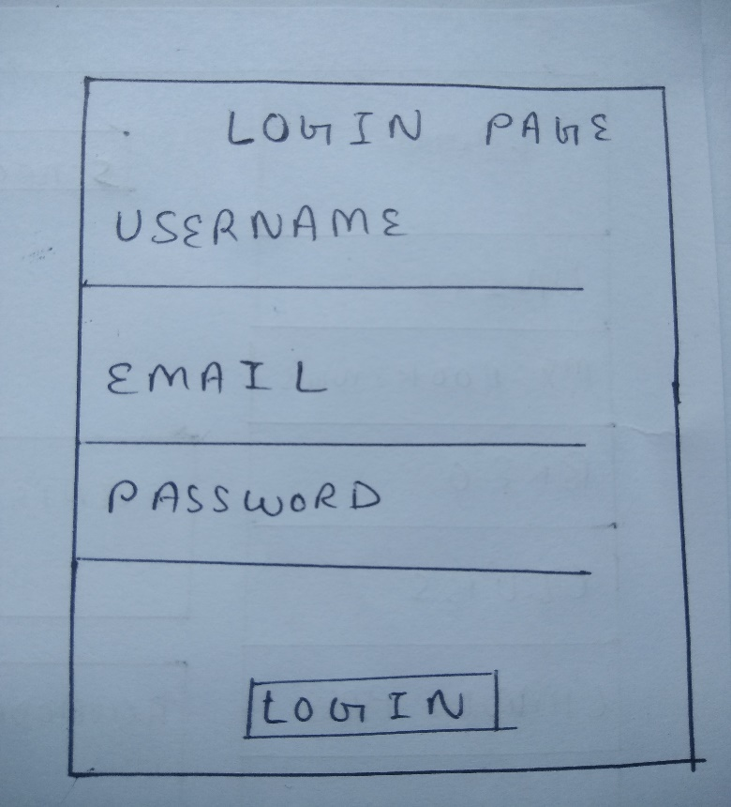

Figure 1 login page

Figure 1 Register page

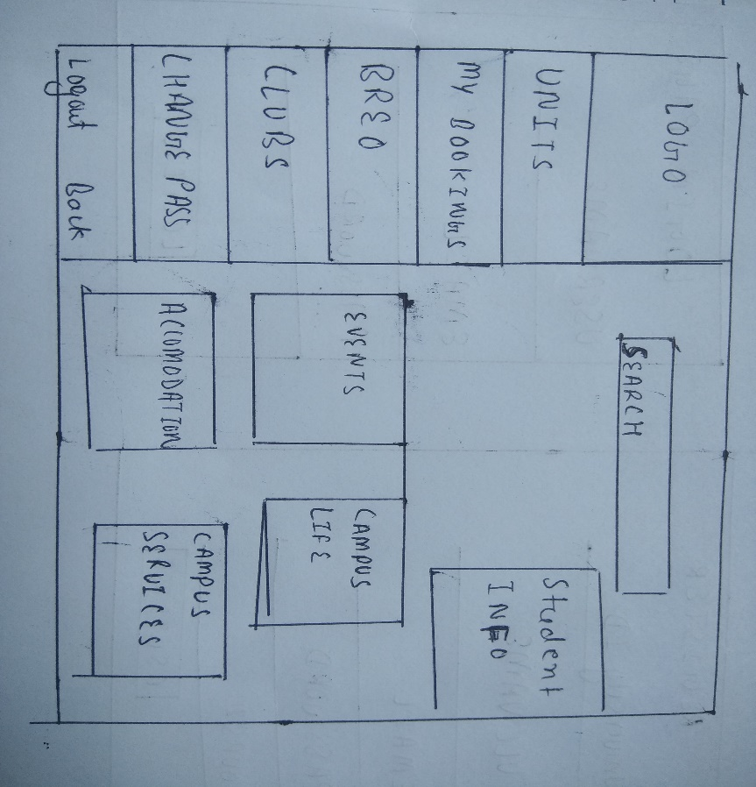

Figure 2 login page

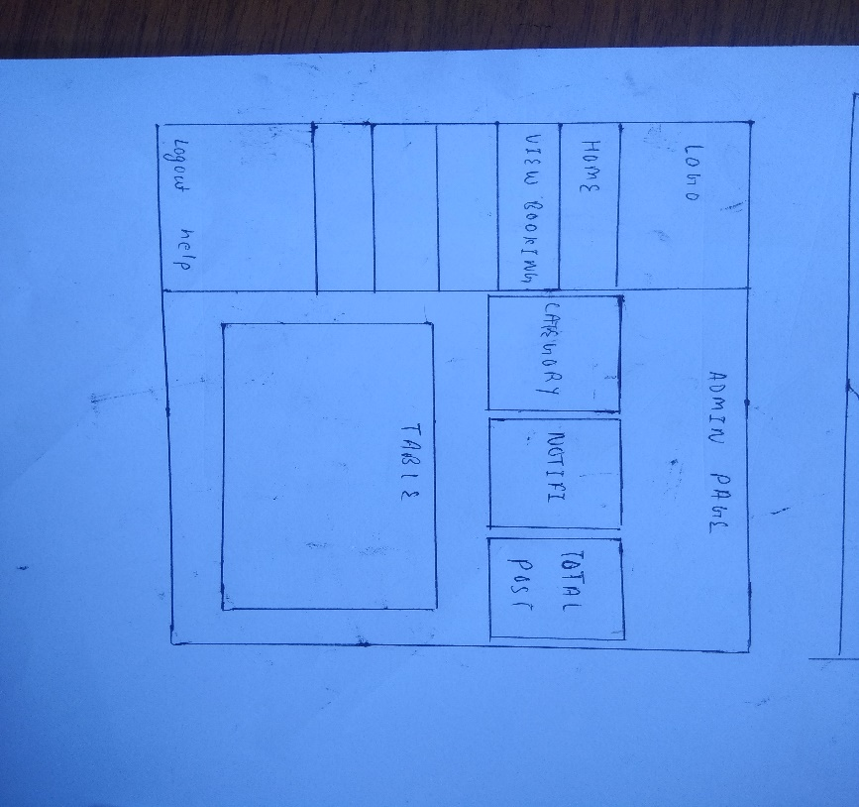

Figure 4 Admin page

Figure 3 Home page

## **Mid Fidelity**

Figure 5 Student Home page

Figure 6 Add Events

Figure 2 Homepage

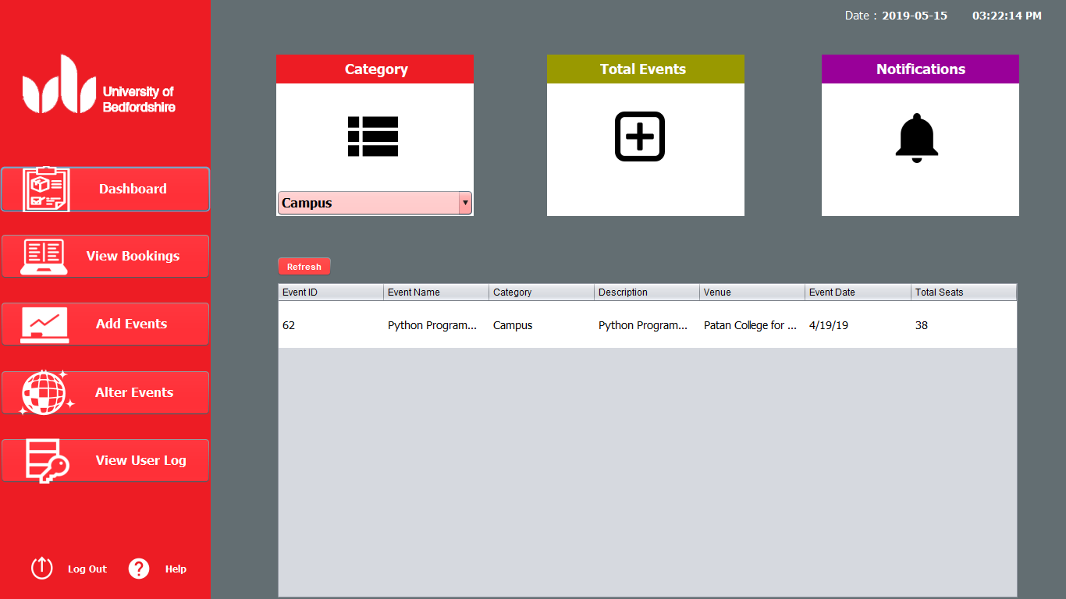

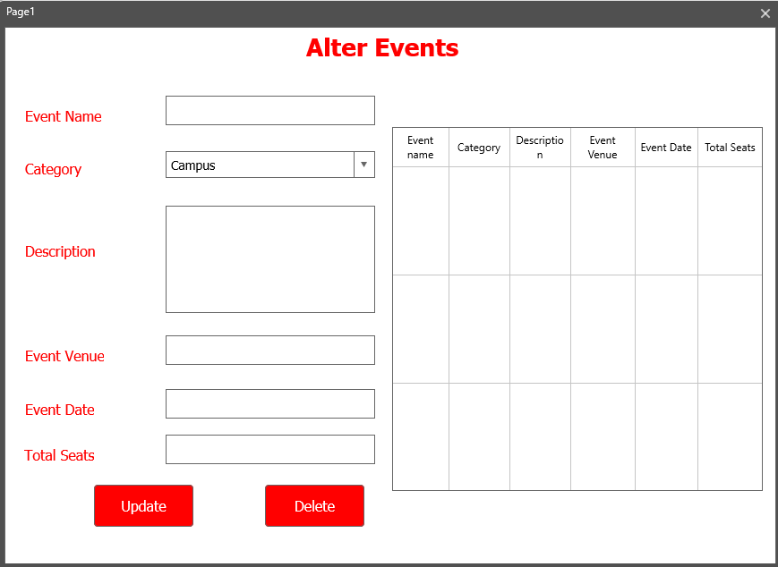

Figure 8 Alter Events

Figure 7 Admin page

## **High Fidelity**

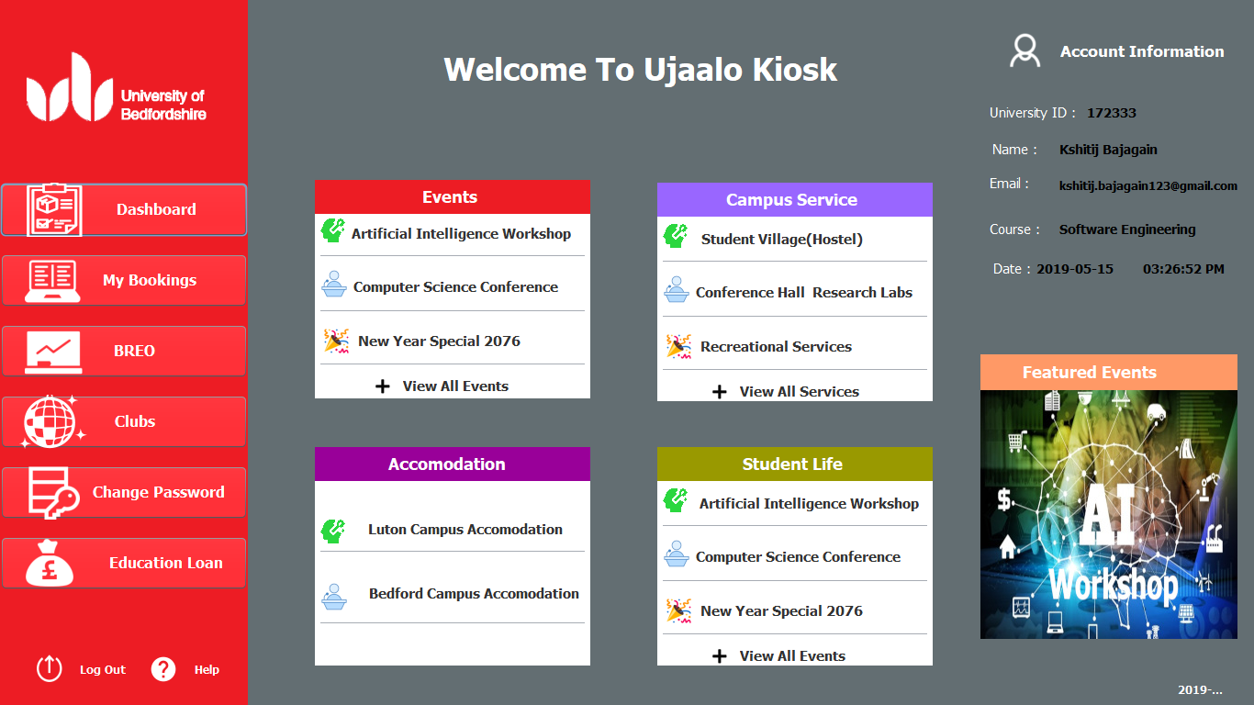

# 

# 

# \\’’’’’’’’’’’’’’’’’’’’

## **Use-case Diagram**

The purpose of a use case diagram in UML is to demonstrate the different ways that a user might interact with a system. In our system as shown in the diagram there are almost three user that can directly or indirectly interact with the system. First user in our system is student himself. Student can register if he/she is newly, than login to the system. Student can enroll courses, view community and campus event, book those events and view his/her booking. Second user in our system is guest who have privilege to view the community events only. Last user in our system is admin who have full control over the system. Admin can add events, update the events and booking details by logging in to system with their valid admin **credentials (username = admin, Gmail=** [**ujaalo@gmail.com**](mailto:ujaalo@gmail.com) **, password = admin)** (Lucidchart.com, 2019)

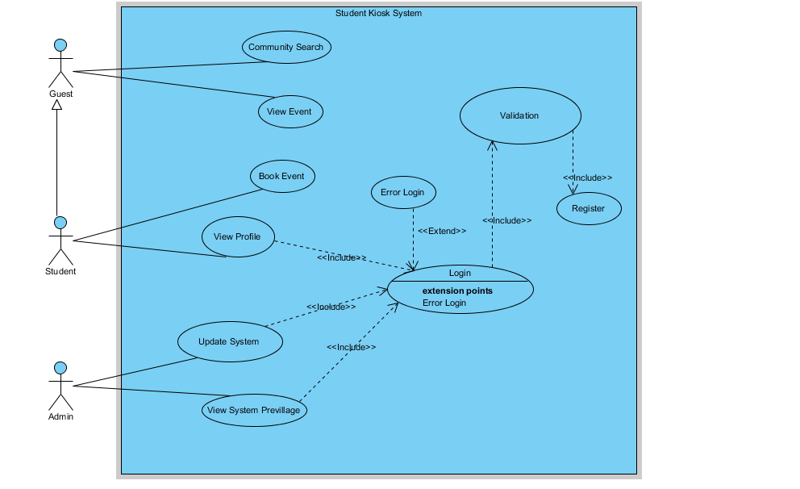

Fig: - Ujaalo Student Information Kiosk Use-case Diagram

## **Activity Diagram**

An activity diagram is essentially a flowchart that shows activities performed by a system. Activity diagram describe what must happen in the system being modeled. There are almost three user that impact on the system. First user in our system is student who have privilege to first view events and campus event than furthermore he/she must login to the system. If the login is successful than student can view student dashboard. In student dashboard student can view his profile, visit to the booking details and logout from the system. Second user of the system is admin. Admin can also view college info than he/she must login to the system. Admin has full privilege of update and cancel each booking details than admin can logout from the system also. The last user of the system is guest who can only visit to the Kiosk home page and view community events and college information.(Lucidchart.com, 2019)

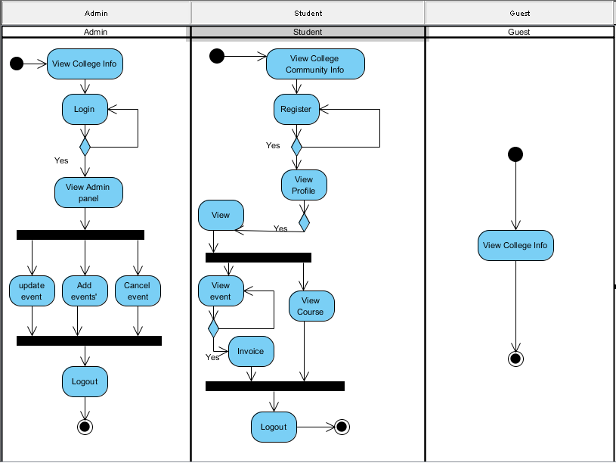

Fig: - Ujaalo Student Information Kiosk Activity Diagram

## **Sequence Diagram**

Sequence diagrams are a popular because they specifically focus on lifelines or the processes and objects that live simultaneously, and the messages exchanged between them to perform a function before the lifeline ends. Almost three users are there in our system but representing three users at the same time in sequence diagram is very difficult and challenge task so we take only student user and represent their lifeline in different system. First of all student open the system and system display the campus and event information in return to student user then student signup and perform various task to the system respond according the user input.(Lucidchart.com, 2019)

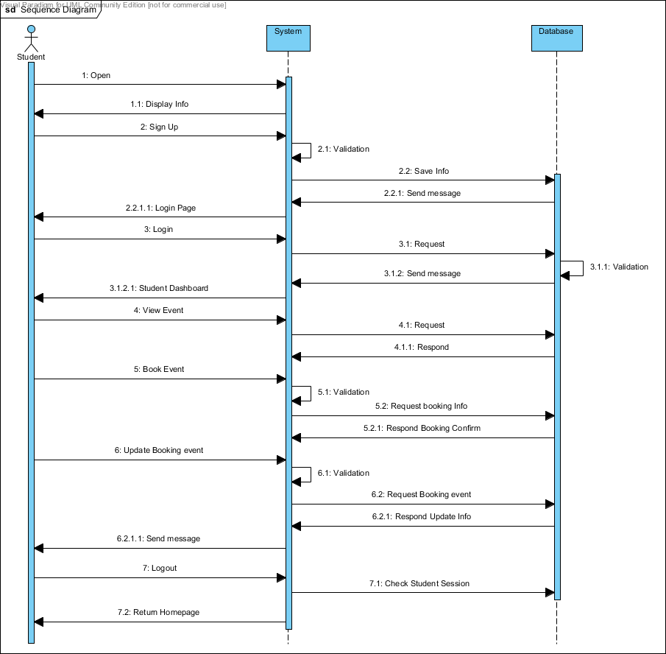

## **Entity Relationship Diagram**

An Entity Relationship (ER) Diagram is a type of flowchart that illustrates how “entities” such as people, objects or concepts relate to each other within a system. Following attested Entity Relationship Diagram explains the relation between tables (along with their attributes) with another table used in our Ujaalo Student Information Kiosk.(Lucidchart.com, 2019)

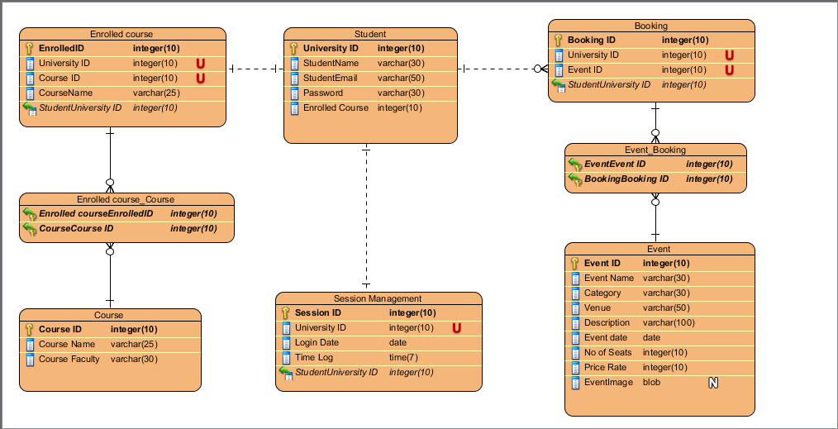

Fig: - Ujaalo Student Information Kiosk Activity Diagram

**In order to login in our system as an admin, default Admin credentials are**

Username = admin,

Gmail= [ujaalo@gmail.com](mailto:ujaalo@gmail.com) ,

Password = admin

## **Class Diagram:**

Another most important diagrams in UML is class diagram. A class diagram is an illustration of the relationships and source code dependencies among classes in the Unified Modeling Language (UML). (Paradigm, 2019)

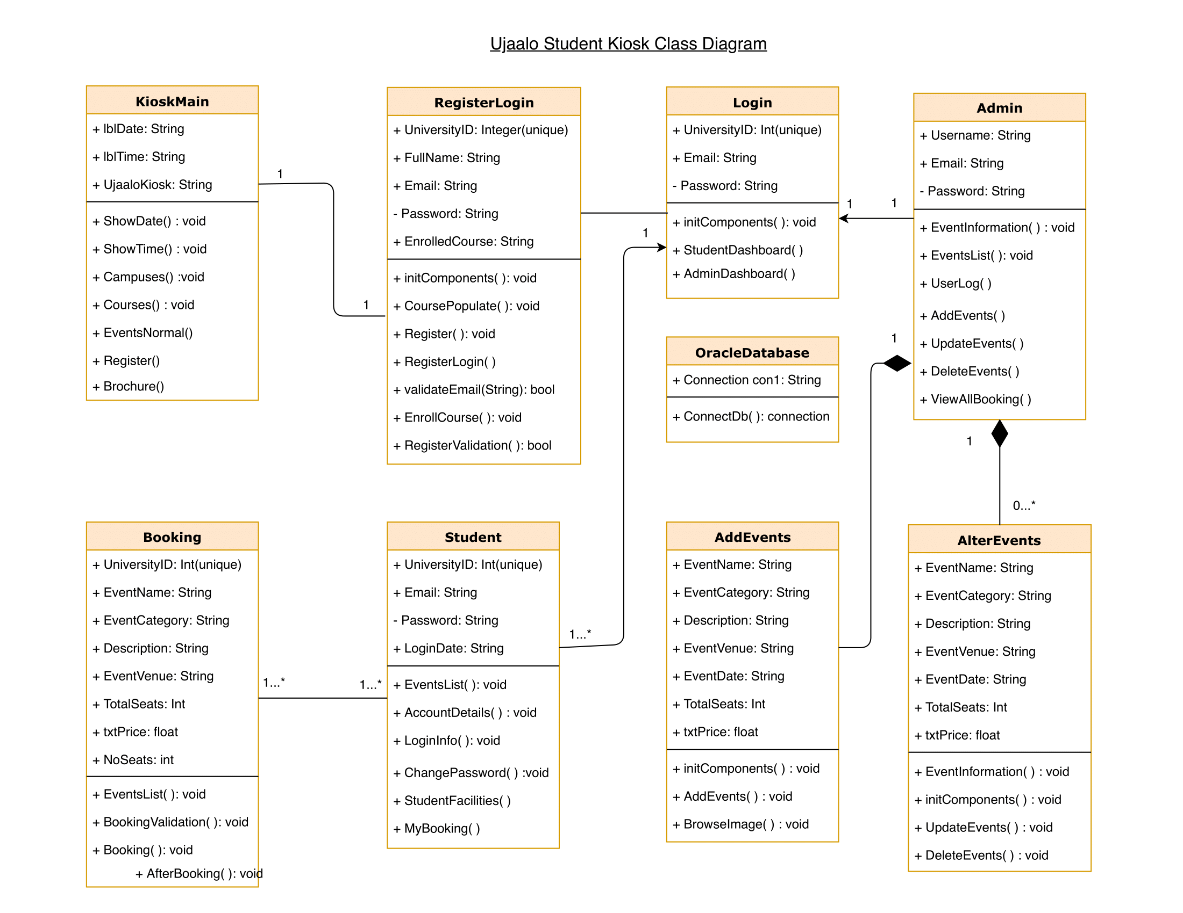

Fig: - Ujaalo Student Information Kiosk Class Diagram

# Market Research

# Primary Research

The main purpose of development of kiosk is to digitalize the campus administration system and effectiveness of daily workflow students and others. After understanding the complete requirements of software proposed by University, we did primary research via various means including questionnaires, one to one conversation, mass communication and brainstorming among group members thus preventing system failure and promoting effectiveness of system. Primary research was conducted among students and college staffs. Various system were observed to find the useful functionality and implement it in our system. Focusing on system effectiveness we followed user center design and various golden rules on design which was also outcome of research various functional and non-functional requirements are categorized and implemented into system. Finally, all those responses of research were discussed among group members and implemented into system along with proposed system requirement.

# Analysis:

From the responses of primary research we came to analyze that 96.7% of people who responded to use system are student out of which 83.3% are international student and 11.7% are national student. Among the users who preferred to use our system, 66.7% agreed that they are facing various problems while gathering various information regarding events and their booking. Among people facing problem regarding events and their booking 73% are looking for digital system like kiosk that helps minimizing their problems because about 55% of responders were unaware of events that are happening inside or outside college premises via traditional means. From all those responses and other means of primary research we came to find that most of the people are seeking for digital platform and we decided that our kiosk system could help to minimize their issues. Hence we developed a complete digital platform that helps to search, book, and update and delete events etc. thus reducing traditional system.

*Note: Refer to link provided in references for questionnaires and their responses of primary research.* (System, 2019)

# 

# Software Methodology

## **Agile Methodology**

Agile project management is an iterative approach to produce product in iter delivery that builds incrementally from the start of the project, instead of trying to deliver the entire product at once near the end. The approach is based on the Agile Manifesto. Agile works by breaking projects down into little bits of user functionality, prioritizing them, and then continuously delivering them in 2-4-week cycles called iterations or sprints. Agile methodologies help to increase team performance, improve customer satisfaction and increase project versatility so our group work on the agile methodology. Agile methodologies are able to respond to market dynamic and complete more of their project successfully. During the project we need end-user involvement. There is need to be continues planning and feedback throughout the development of project. So, choose to work on agile methodology as agile methodology also increase control over the project by daily sprint meeting and transparency through information radiators. Agile gives freedom when recent changes need to be implemented. Here is bi-weekly sprint we made throughout the project.

Sprint of Ujaalo Student Kiosk:

### Sprint 1

|  |  |  |  |
| --- | --- | --- | --- |
| Week | User story | Tasks | Working hours |
| Week 6 | As member everybody could visualize system architecture and find the requirement of the end user | Use case diagram and activity diagram | 20hrs |
| Week 7 | Every group member gathers with their own design and diagram. | Sequence diagram and prototyping of homepage of kiosk. | 10hrs |

Sprint name: Initial sprint

Start-end date: 2019/3/7 – 2019/3/14

Sprint goal: complete almost diagram and implement at least design in through development.

### Sprint 2

|  |  |  |  |
| --- | --- | --- | --- |
| Week | User story | Tasks | Working hours |
| Week 7 | Every group member gathers with their own design and diagram. | Sequence diagram and prototyping of homepage of kiosk. | 10hrs |

Sprint name: Prototype Sprint

Start-end date: 2019/3/14 – 2019/3/21

Sprint goal: complete all diagram and implement designs in java

### Sprint 3

|  |  |  |  |
| --- | --- | --- | --- |
| Week | User story | Task | Working hours |
| Week 8 | As every member of the group can visualize the structure of the database and can visualize complete system | Working on Entity relationship diagram and also started to work on oracle database | 5hrs |

Sprint name: Database I sprint.

Start -End date: 2019/3/21 – 2019/4/28

Sprint goal: complete first prototype of all system with the user requirement.

### Sprint 4

|  |  |  |  |
| --- | --- | --- | --- |
| Week | User story | Task | Working hours |
| Week 9 | As every member of the group started to work on the prototype design in mock plus and adobe XD and started primary research. | Working on prototype and database and started to interaction with student and campus staff to find out the system requirement. | 2hrs |

Sprint name: Database II sprint.

Start -End date: 2019/3/28 – 2019/4/15

Sprint goal: Starting primary research to make our project more effective.

### Sprint 5

|  |  |  |  |
| --- | --- | --- | --- |
| Week | User story | Task | Working hours |
| Week 10 | As every member of the group started to check the functionality of the system also working on refine the prototype (Focus on UCD) | Working on student dashboard and admin dashboard | 20hrs |

Sprint name: Development Sprint

Start-end date: 2019/4/26 – 2019/5/3

Sprint goal: To connect database and work on session of individual students.

### Sprint 6

|  |  |  |  |
| --- | --- | --- | --- |
| Week | User story | Task | Working hours |
| Week 11 | Connect the database to the system and stored the student data to oracle database | Working on the student and admin panel by register individual student and stored that data to oracle database and also working on the session of student. | 15hrs |

Sprint name: session management

Start-end date: 2019/5/3 – 2019/5/10

Sprint goal: To complete work on session of individual students.

### Sprint 7

|  |  |  |  |
| --- | --- | --- | --- |
| Week | User story | Task | Working hours |
| Week 12 | Every Member of group started to focus on user centric design | Testing was performed | 20hrs |

Sprint name: Testing

Start-end date: 2019/5/10 – 2019/5/17

Sprint goal: To perform final testing.

### Sprint 8

|  |  |  |  |
| --- | --- | --- | --- |
| Week | User story | Task | Working hours |
| Week 13 | Every member in group was focus on refining the project | New function was added in admin | 20hrs |

Sprint name: Final project

Start-end date: 2019/5/17 – 2019/5/24

Sprint goal: To refine the project to make system user friendly.

*Note: Refer to link provided in references for sprints of Ujaalo student information Kiosk* (Kiosk, 2019)

# Project Plan

In Week 5, we formed our group. We had assigned work to each group member and started work according. We were strictly following our weekly plan to complete our task.

|  |  |  |  |  |  |
| --- | --- | --- | --- | --- | --- |
| Week No | Task completed | Task planned for next week | Issues faced in this week | Submitted date | Supervisor Comment |
| 6 | Use case and activity diagram  Prototyping of home page  Registration and login page implemented in java | Implementing homepage in java  Sequence Diagram  Low fidelity of user page | Scrollable jpanel | 2019/3/14 | Complete UML diagrams before initialing development work  Implement all relevant diagram into coding |
| 7 | Implementation home page in java  Sequence Diagram  Low fidelity of user page | Home page refining  Refining Entity relation diagram | Use case was not correct  Primitive homepage | 2019/3/21 | Rectify Use case diagram |
| 8 | Homepage refined  User homepage was implemented in java  Entity relationship diagram refined | User homepage functionality refined  Admin mid and low fidelity | Database schema was not correct  Problem in API development | 2019/3/28 | Implement GUI based on the prototype you guys have developed |
| 9 | Admin mid and low fidelity  Refining GUI of user page  Refine database Schema | Database Connection  Complete functionality of user  Refining the medium fidelity | Problem in database connection (fetching user Information after logging into system) | 2019/4/26 | Work on the database connectivity and refine GUI |
| 10 | Database connection  Remaining functionality of user (Change password, my booking)  Refine admin GUI | Session management  Prepare pdfs (help, broucher, student loan)  Refining admin | Word-wrap in Jtable  Fetching data in jtable | 2019/5/3 | Focus on Session management  Add functionality |
| 11 | Refining the functionality of admin  Work on session  PDF for help, student and brochure | Complete session management  Testing | Issue in database  Word-wrap in jtable | 2019/5/10 | Work on minor obstacles  Add functionality on admin/system |

Note: From April 4 to April 20, there was our internal exam as well as sport week. So, we have prepared for our internal exam and involve in games. We were also conducting meetings and discussing about project.

# Testing:

**Register Testing**

|  |  |  |  |
| --- | --- | --- | --- |
| Module | Expected Result | Actual Result | Result |
| Register | Student register with full name, email, university id and password. When one field is empty register is unsuccessful. | Student can register with full name, university id, email and password only. | Pass |

**Login Testing**

|  |  |  |  |
| --- | --- | --- | --- |
| Module | Expected Result | Actual Result | Result |
| Login | Student login with email, student id and password. | Student can login with email, password and password only. | Pass |

**Session Testing**

|  |  |  |  |
| --- | --- | --- | --- |
| Module | Expected Result | Actual Result | Result |
| Session | When one student login to the system his/her information is shown in dashboard. | Student can view only their own profile and booking details. | Pass |

**Homepage Testing**

|  |  |  |  |
| --- | --- | --- | --- |
| Module | Expected Result | Actual Result | Result |
| Homepage | Student can view his/her profile, booking and logout from system. | Student can view profile, booking and campus events. | Pass |

**Add Events**

|  |  |  |  |
| --- | --- | --- | --- |
| Module | Expected Result | Actual Result | Result |
| Add events | Admin can add campus events and store to the database | Admin add new events to the system. | Pass |

**View Booking**

|  |  |  |  |
| --- | --- | --- | --- |
| Module | Expected Result | Actual Result | Result |
| View booking | Student can view their booking. | Students can view their own booking. | Pass |

**View Events**

|  |  |  |  |
| --- | --- | --- | --- |
| Module | Expected Result | Actual Result | Result |
| View events | Students can view all events on homepage of the system. | Student can view both campus and community events | Pass |

**Alter Events**

|  |  |  |  |
| --- | --- | --- | --- |
| Module | Expected Result | Actual Result | Result |
| Alter events | Admin can update the events details. | Admin can update the events details. | Pass |

**Delete Booking**

|  |  |  |  |
| --- | --- | --- | --- |
| Module | Expected Result | Actual Result | Result |
| Delete booking | Student can delete booking if he/she wants. | Students can delete booking. | Pass |

# Critical Analysis

As per the assignment given by the university, we have got huge opportunities to learn a new thing as well as to implement our previous skill and knowledge in the project. We have got opportunities to build the desktop application using oracle database and java programming knowledge. So, in this project we learn about oracle database and implement in our project we have also learn about software methodology and how to implement those methodologies according to our project. In our project we applied agile software methodology, so we learn more about agile software methodology. The main this purpose assignment is only engaged the student with limited resources and the scope of project is narrow because it only covers the college and student so the assignment should give to solved real world problem rather than particular problem and the platform should we web rather than desktop application because it reaches a lot of the people. So have learn a lot of thing from this project but this project cannot reach a many of the people. So further development of the project we implement the whole project through the web application so it can reach many people and student can either run through mobile and laptop. (Beyer, 2018)

# Conclusion

From this project we chance to learned about so many new things and we also implement our previous skilled and knowledge in this project. During the project so many difficulties and obstacle are come but we tackle each obstacle with group member and assignment coordinate. Before starting this project, we all gathered the requirement from college administration, students and other such kind of system then we analyze the requirement as per the demand of the assignment and development is started. So, we hope that our system will solve the campus administration and help student for sharing information.

# References

* Beyer, J. (2018). Writing Critical Analysis Papers. Critically Analyzing an Academic Article or Book.
* Fitsmallbusiness.com. (2019, 05 5). What is a Kiosk? Retrieved from Fitsmallbusiness: https://fitsmallbusiness.com/what-is-a-kiosk-examples/
* Kiosk, U. S. (2019, 5 20). Ujaalo Student Sprints. Retrieved from Google.com: https://drive.google.com/drive/folders/1CRcS9Ts8_NIm2IArG6I1VXQ3s5SN6J2u?fbclid=IwAR2bDInnarxMRp-cKZqg7o762Buy70bfnC_QDeVXYPAAmsx88aBJJVuMq_U
* Lucidchart.com. (2019, 05 18). UML Use Case Diagram Tutorial. Retrieved from lucidchart: https://www.lucidchart.com/pages/uml-use-case-diagram
* Paradigm, V. (2019, 05 27). What is Class Diagram? Retrieved from Visual Paradigm: Visual-paradigmcom. 2019. Visual-paradigmcom. [Online]. [27 May 2019]. Available from: https://www.visual-paradigm.com/guide/uml-unified-modeling-language/what-is-class-diagram/
* System, U. K. (2019, 05 11). Student Information Gathering System. Retrieved from docs.google.com: https://docs.google.com/forms/d/1dgSf72ApA9MXTm42Ey1Uj6KuZcH2CoRw8rJbhLsLw9Q/edit?fbclid=IwAR3m1b8t3IpmHnmRQz0dT9xNYEvAUlUQAwctJa4UmrsJMkb0kDWvjV7x9rg#responses

# Appendix:

Graphical User Interface:

1. Kiosk Main Page :

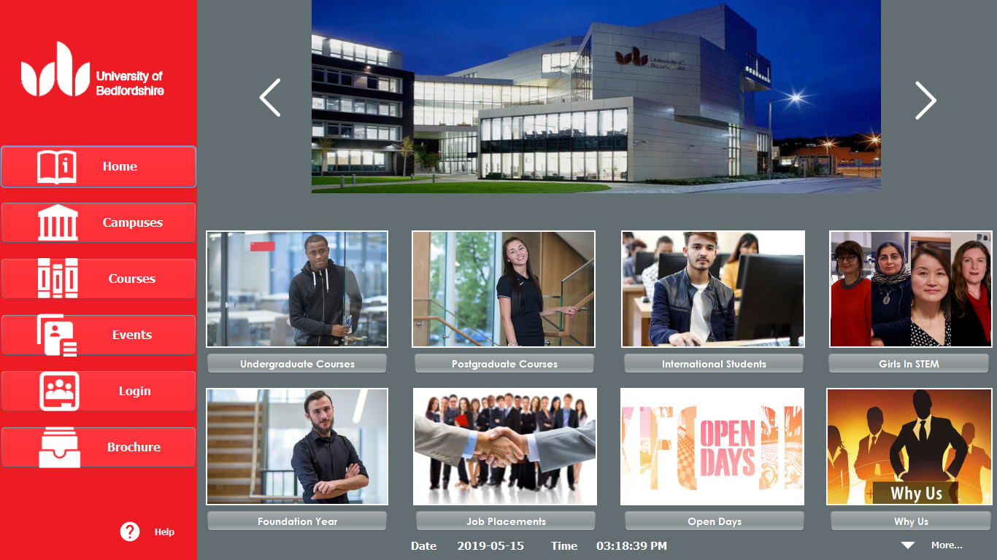

2>Campuses:

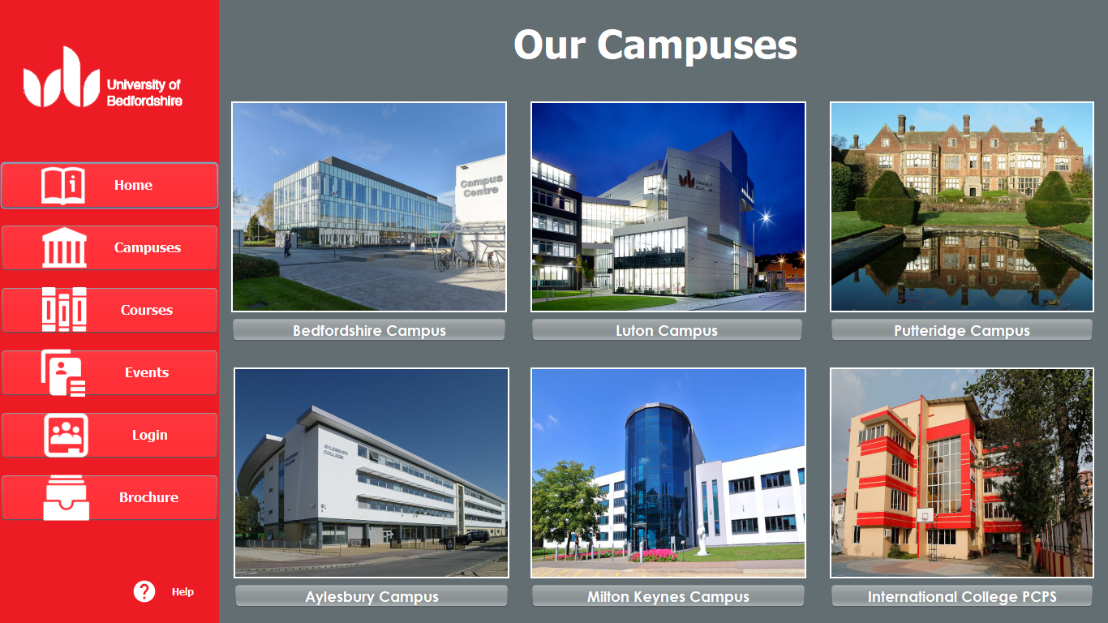

3>Campus About:

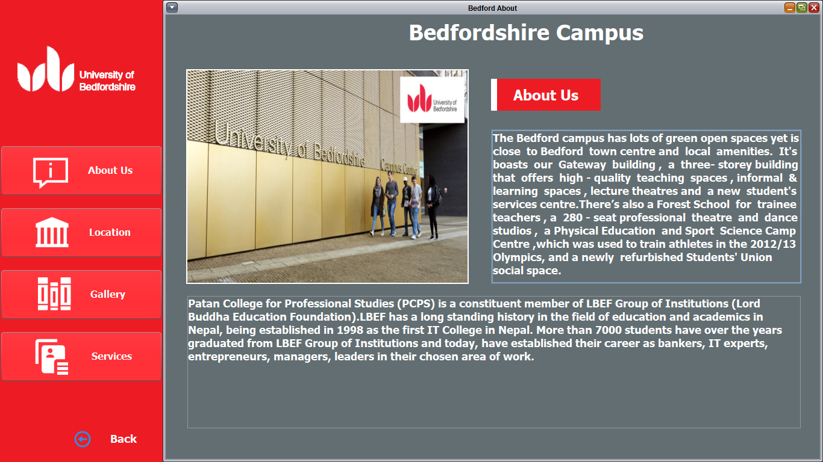

4>Campus Location:

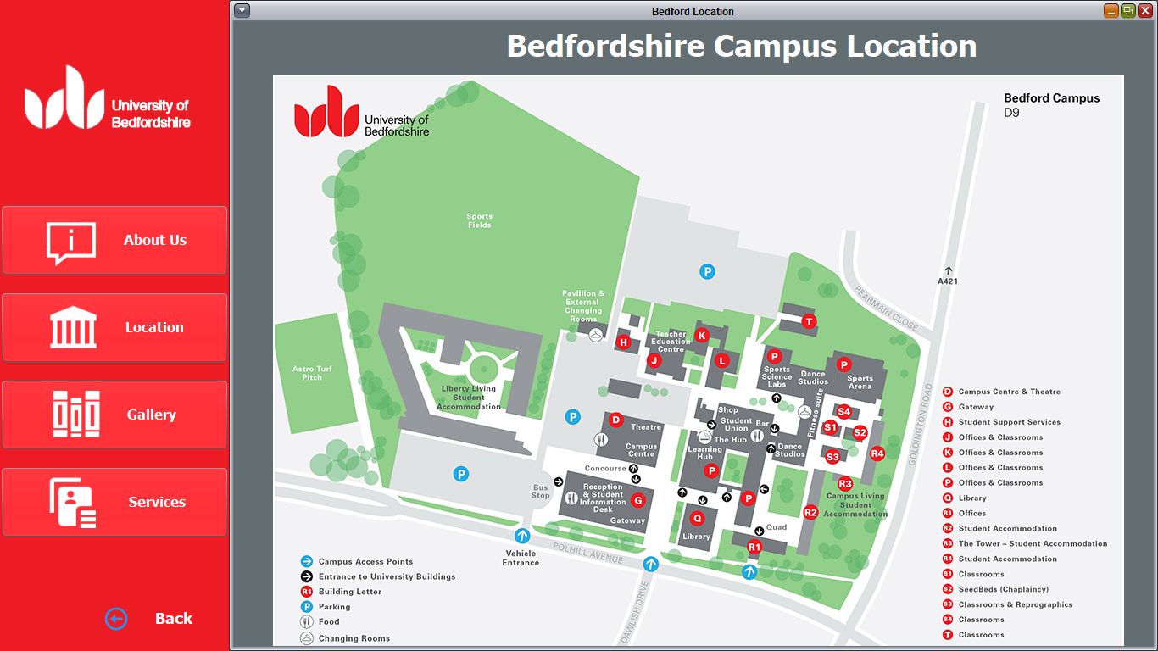

5> Campus Gallery:

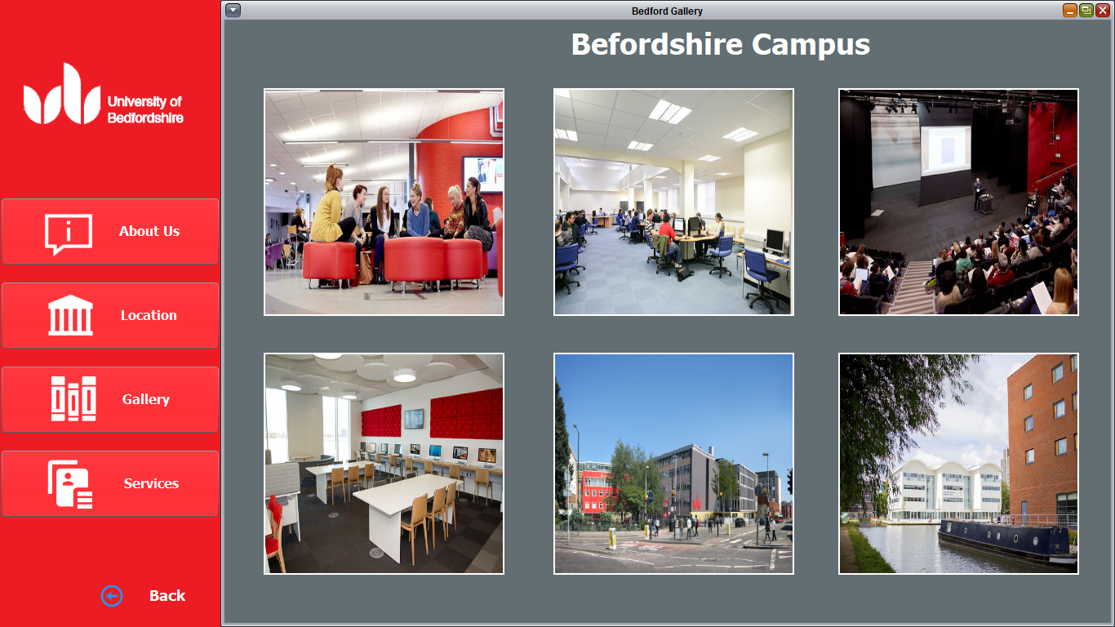

6>Courses:

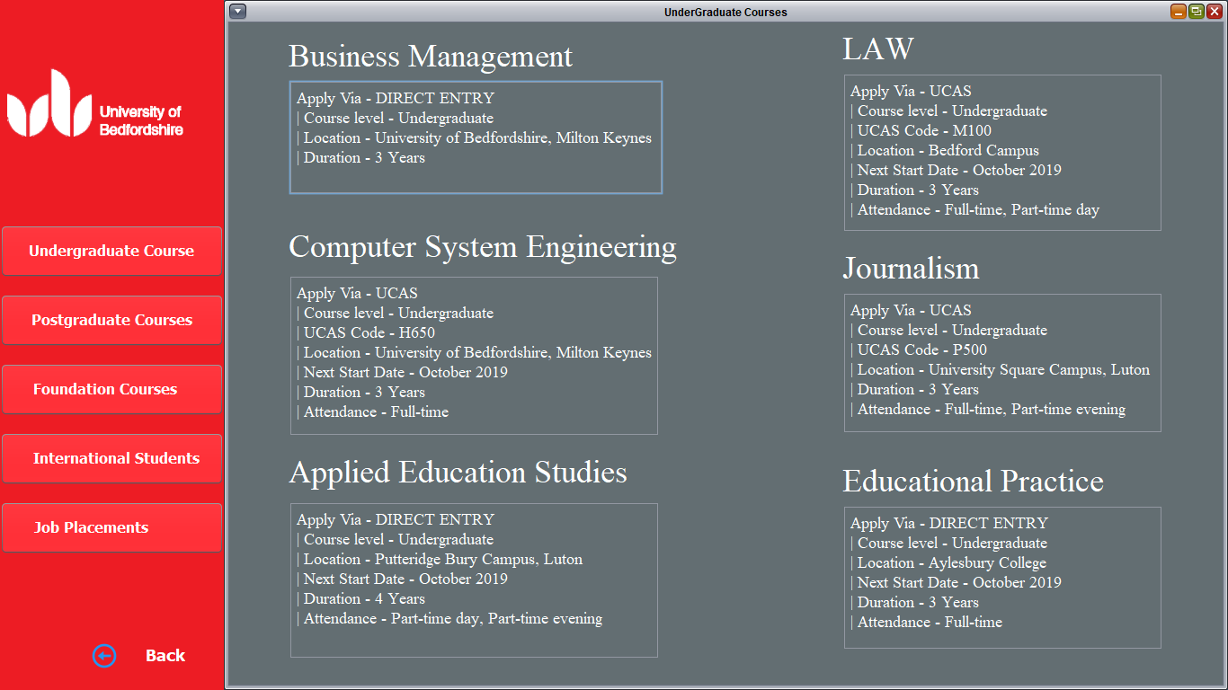

7> Campus Services:

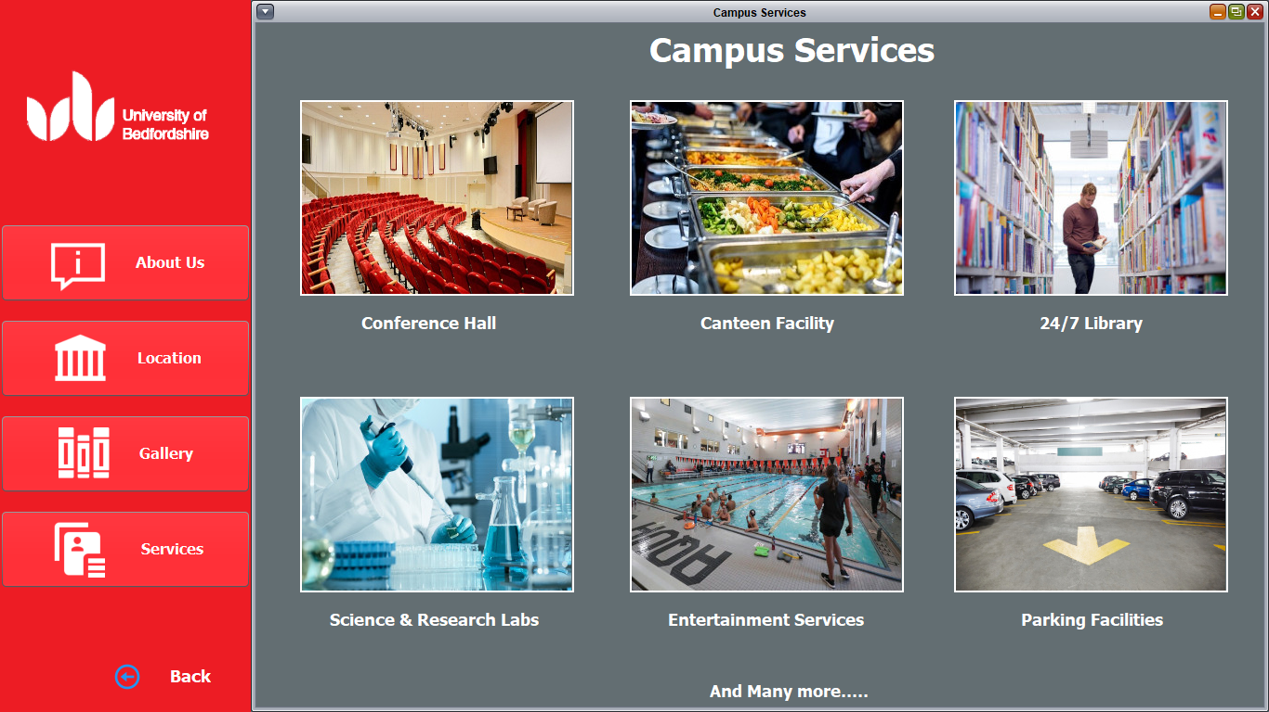

8> Login and Register:

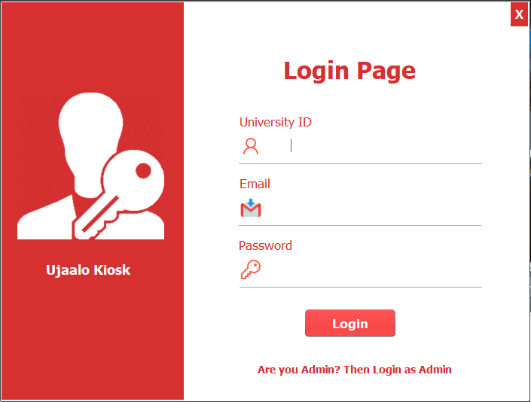

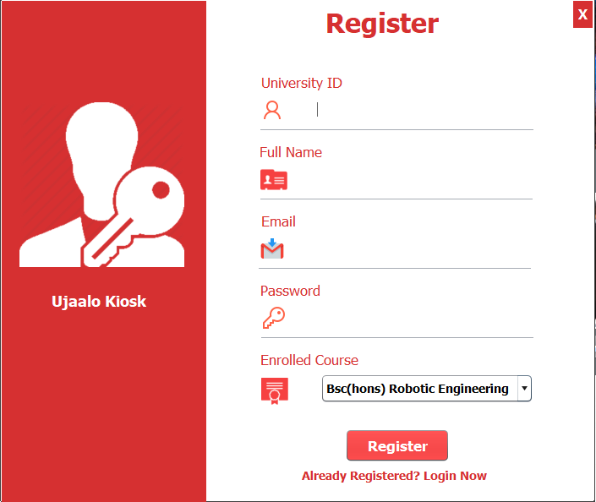

9> Student Dashboard:



10> Student My Booking:

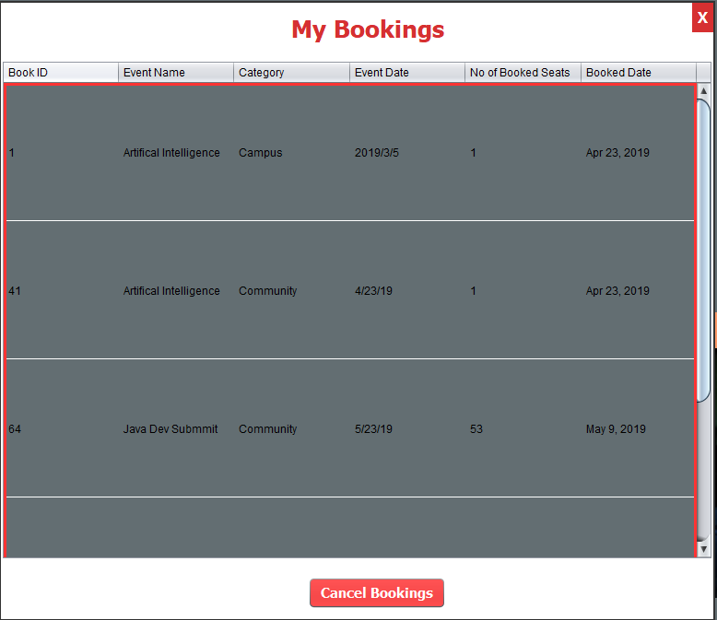

11> Student BREO:

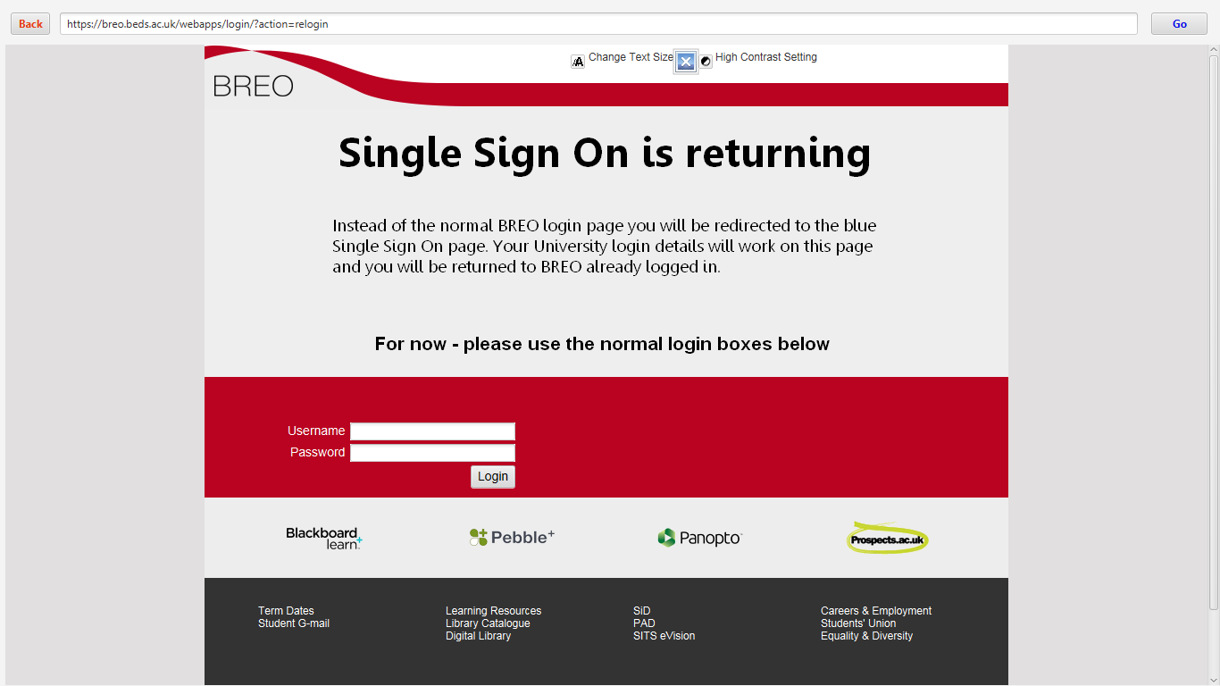

12> Clubs:

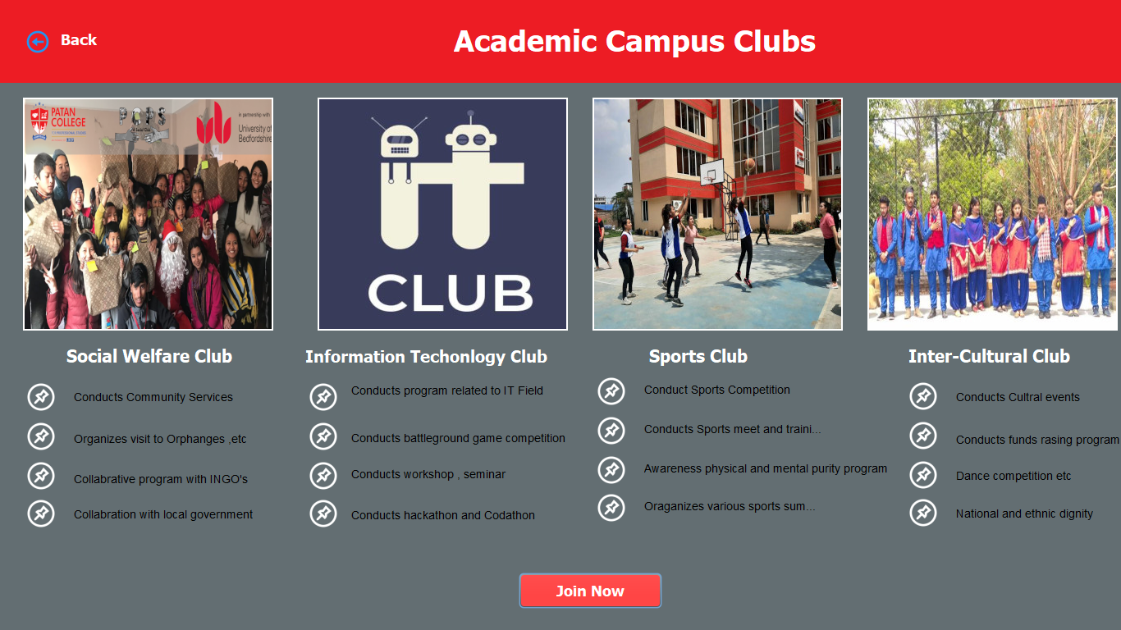

13> Events (Main):

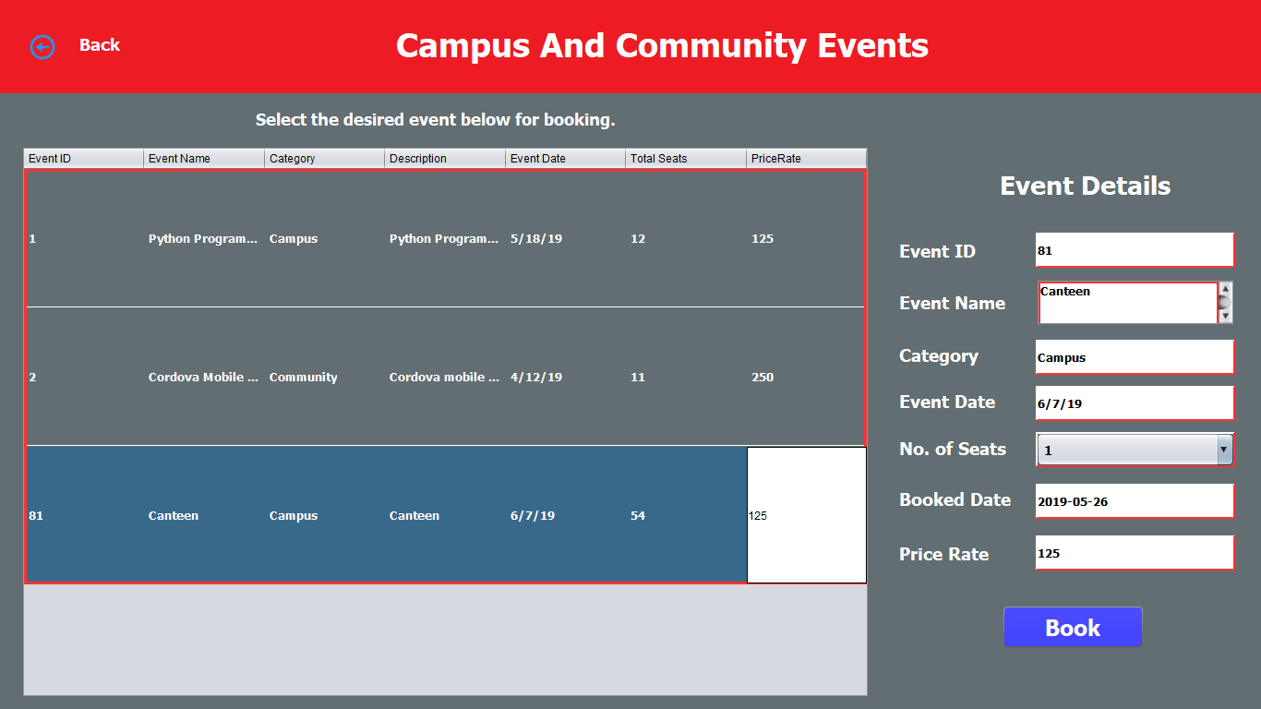

14> Instant Bill Generation:

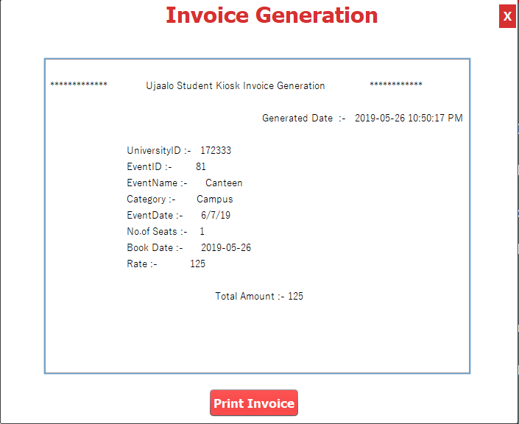

15>Change Password:

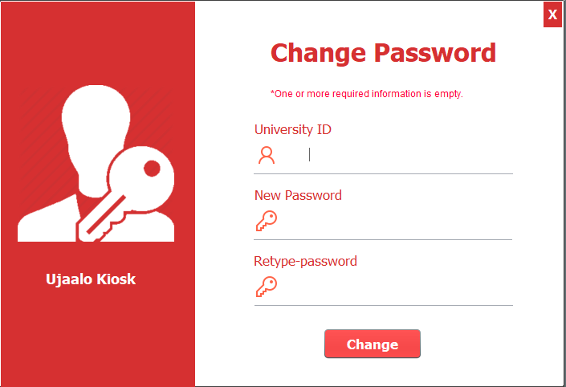

16> Education Loan:

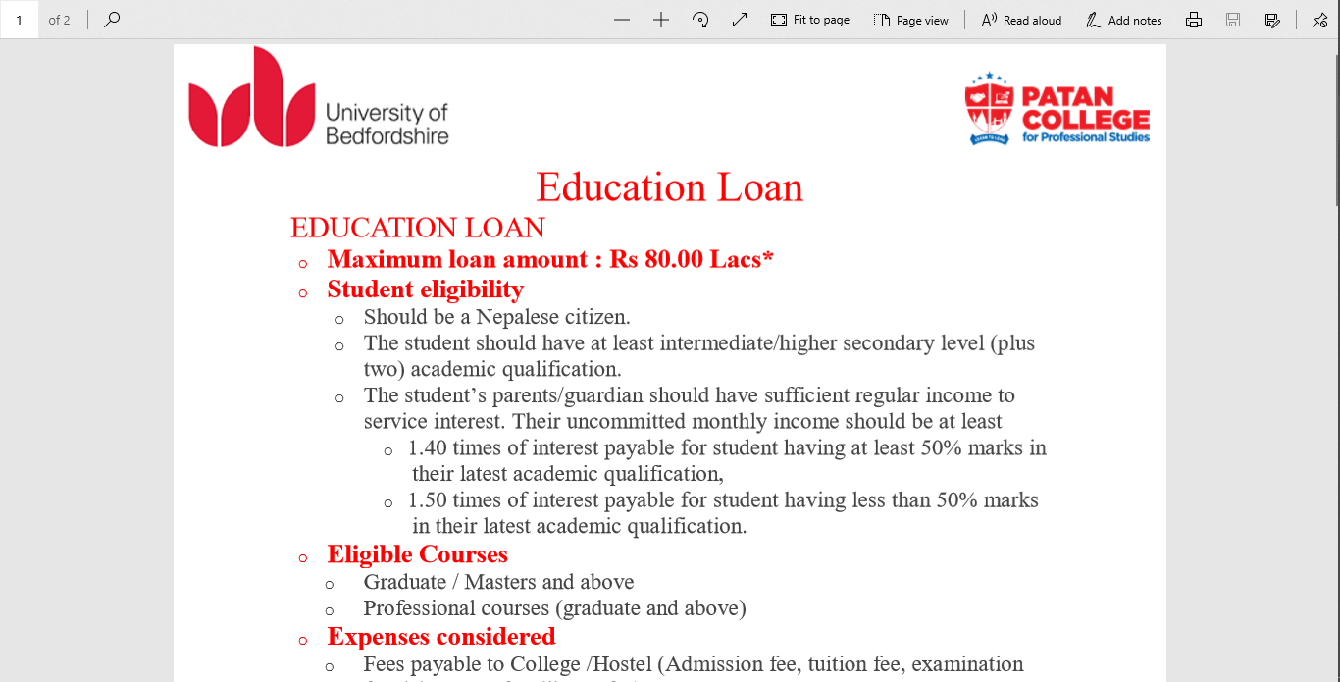

17> Admin Dashboard:

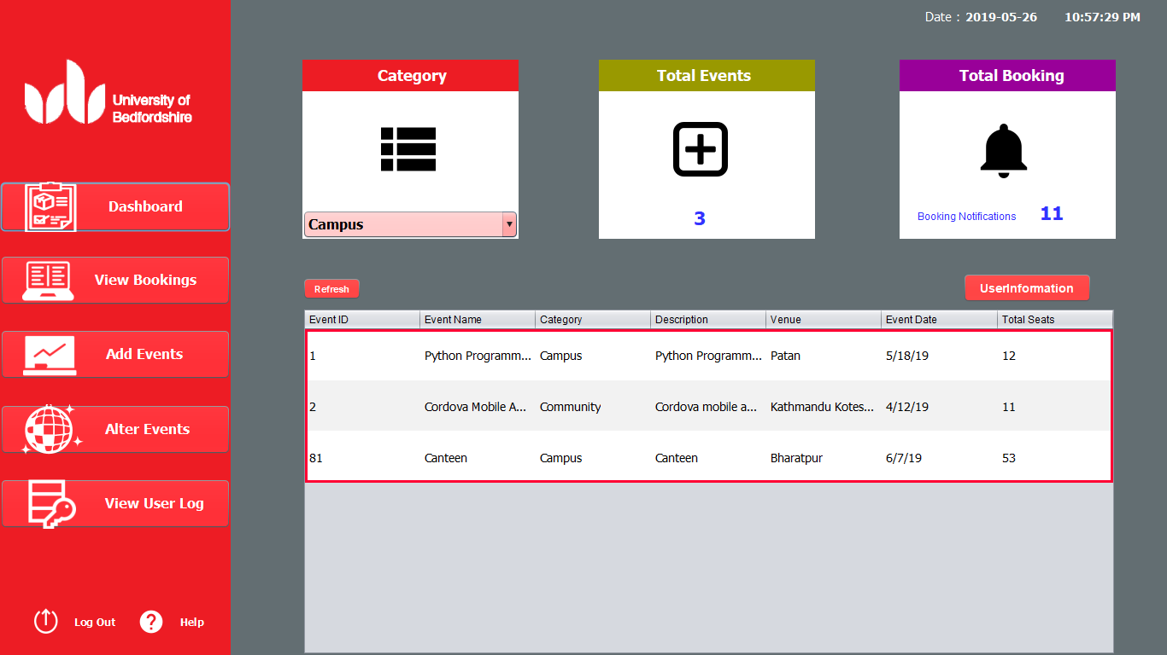

18> View all Booking:

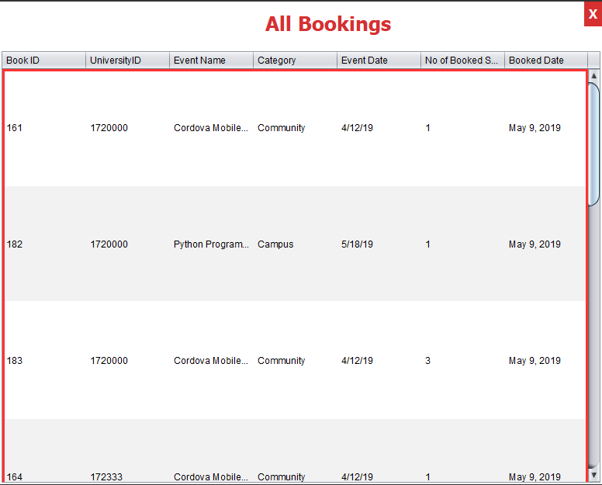

19>Add Events:

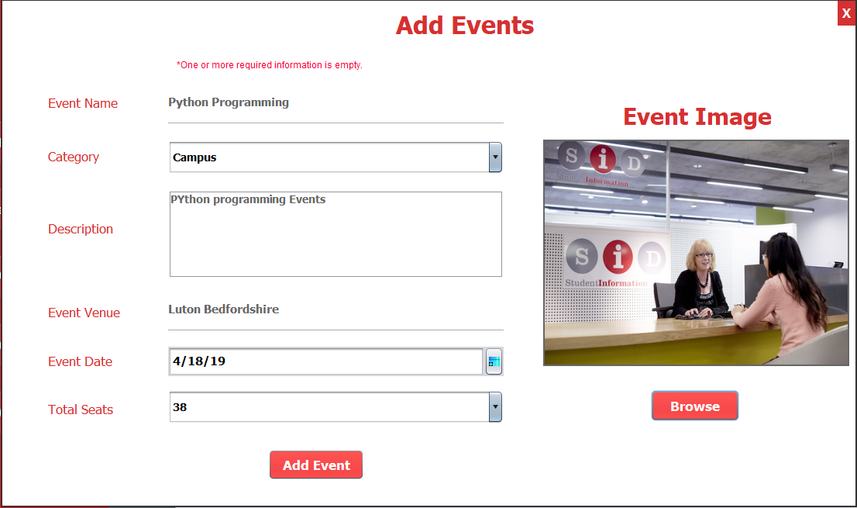

20> Alter (Update and Delete) Events:

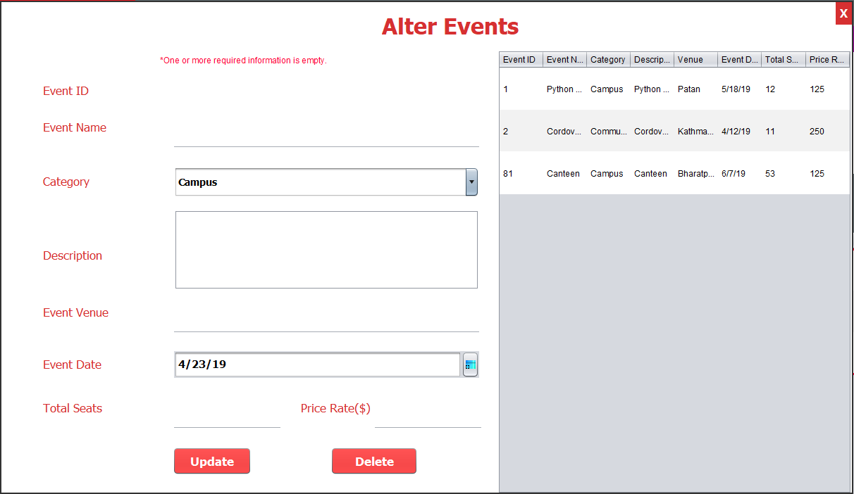

21>View User Log:

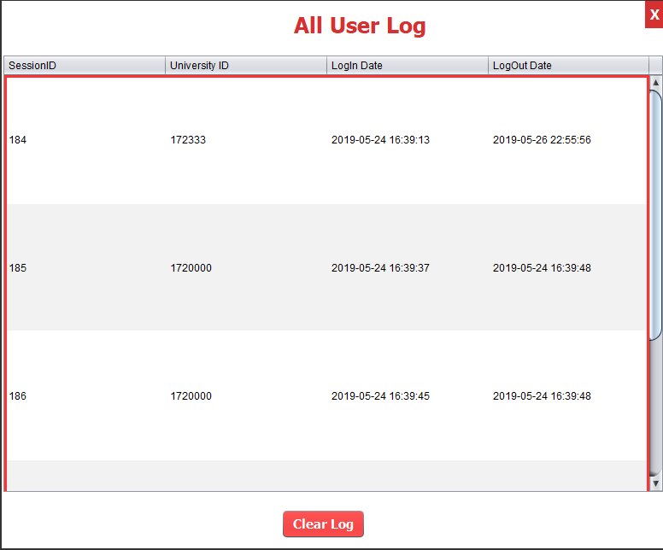

22> Edit User (Student Information):

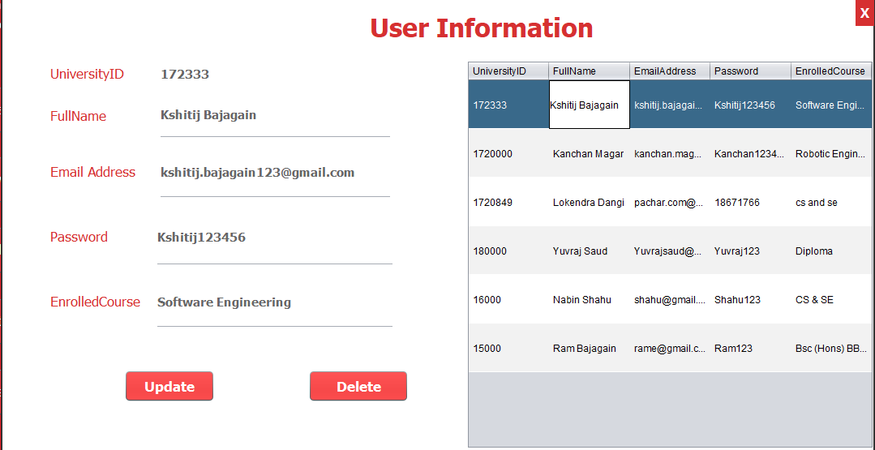

Note: All the codes of whole software are submitted in zip file.